Topic- Text Pattern Matching Tool
Tripti Vishwakarma
Colorado State University Global
Course Code: CSC506 – 1
Dr. Dong Nguyen
Dec 22, 2024

Title: Analysis and Optimization of KMP and Rabin-Karp Algorithms in a Text Pattern Matcher Tool
Introduction
In the realm of data analysis and information retrieval, efficient text searching is crucial. The Text Pattern Matcher tool leverages the Knuth-Morris-Pratt (KMP) and Rabin-Karp algorithms to fulfill this need. This paper explores the purpose of the tool, the challenges faced during its development, the skills acquired and provides a detailed analysis of the empirical data to identify time and space complexity trends. It also discusses optimizations implemented to improve algorithm performance.

Program Purpose
The Text Pattern Matcher tool is designed to serve researchers, developers, and data analysts by providing:
- Efficient Pattern Search: Utilizing KMP and Rabin-Karp algorithms, the tool swiftly searches for patterns within large text datasets.
- Highlighting Matches: Allows users to visualize pattern occurrences, enhancing clarity and further analysis.
- Performance Comparison: Users can compare the efficiency of KMP and Rabin-Karp under various conditions, aiding in selecting the appropriate algorithm for specific tasks.

Obstacles Faced During Development
- Algorithmic Complexity: Implementing KMP and Rabin-Karp required understanding complex theoretical concepts and handling edge cases such as overlapping patterns and hash collisions.
- Performance Optimization: Ensuring efficient performance across different text sizes and patterns required extensive testing and optimization.
- Input Generation and Testing: Developing comprehensive test cases was necessary to ensure reliability and robustness across diverse scenarios.

Skills Acquired
- Algorithm Development: Enhanced understanding of algorithmic efficiency and problem-solving skills.
- Software Engineering: Improved skills in modular coding practices, facilitating easier testing and maintenance.
- Data Analysis: Gained experience in collecting and analyzing empirical data to evaluate algorithm performance.

Empirical Data Analysis
Time and Space Complexity
- KMP Algorithm: Exhibits a time complexity of O(n + m) where n is the length of the text and m is the length of the pattern. Space complexity is primarily determined by the LPS array, which is O(m).
- Rabin-Karp Algorithm: Shows an average-case time complexity of O(n + m) but can degrade to O(n*m) in the worst-case scenario due to hash collisions. Space complexity is O(1) for the hash calculations.
Performance Comparison
Strengths:
  - KMP: Consistently fast for single, long pattern searches due to efficient skipping of non-matching sections.
  - Rabin-Karp: Effective for searching multiple patterns simultaneously, benefitting from its hashing mechanism.
Weaknesses:
  - KMP: Less efficient for multiple pattern searches due to the need to compute multiple LPS arrays.
  - Rabin-Karp: Hash collisions can lead to false positives, necessitating additional verification steps.
Optimizations Implemented
- KMP: Improved LPS array computation to handle specific edge cases more efficiently.
- Rabin-Karp: Enhanced hash function to reduce collision probability and implemented double hashing to verify matches more efficiently.
Knuth-Morris Pratt (KMP) Algorithm
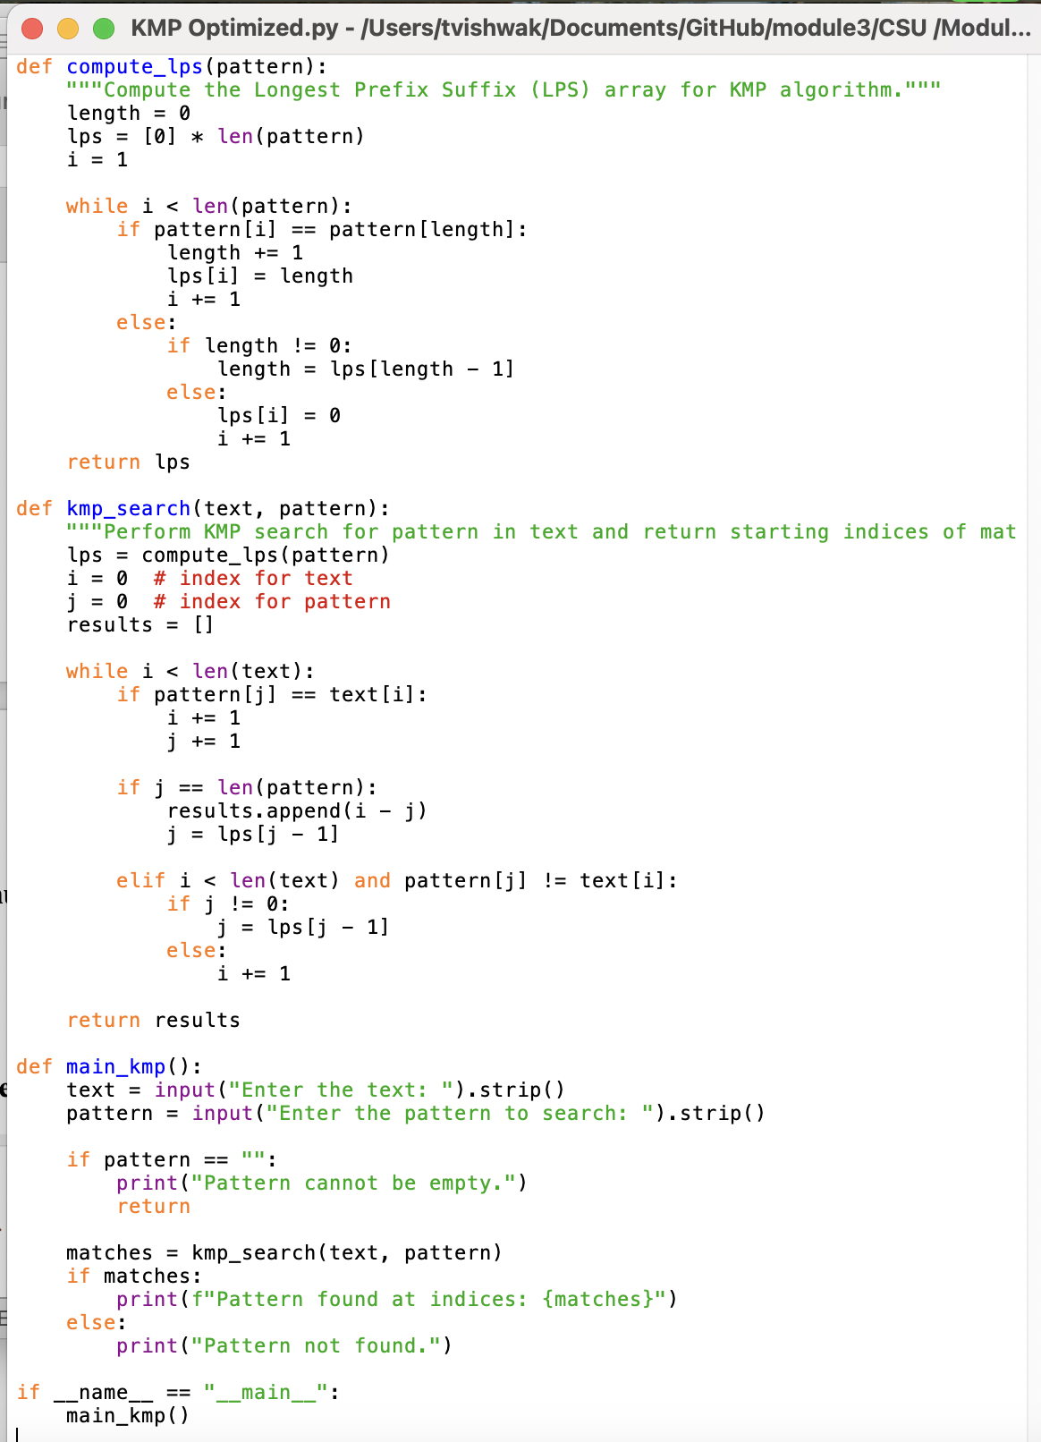

Execution-
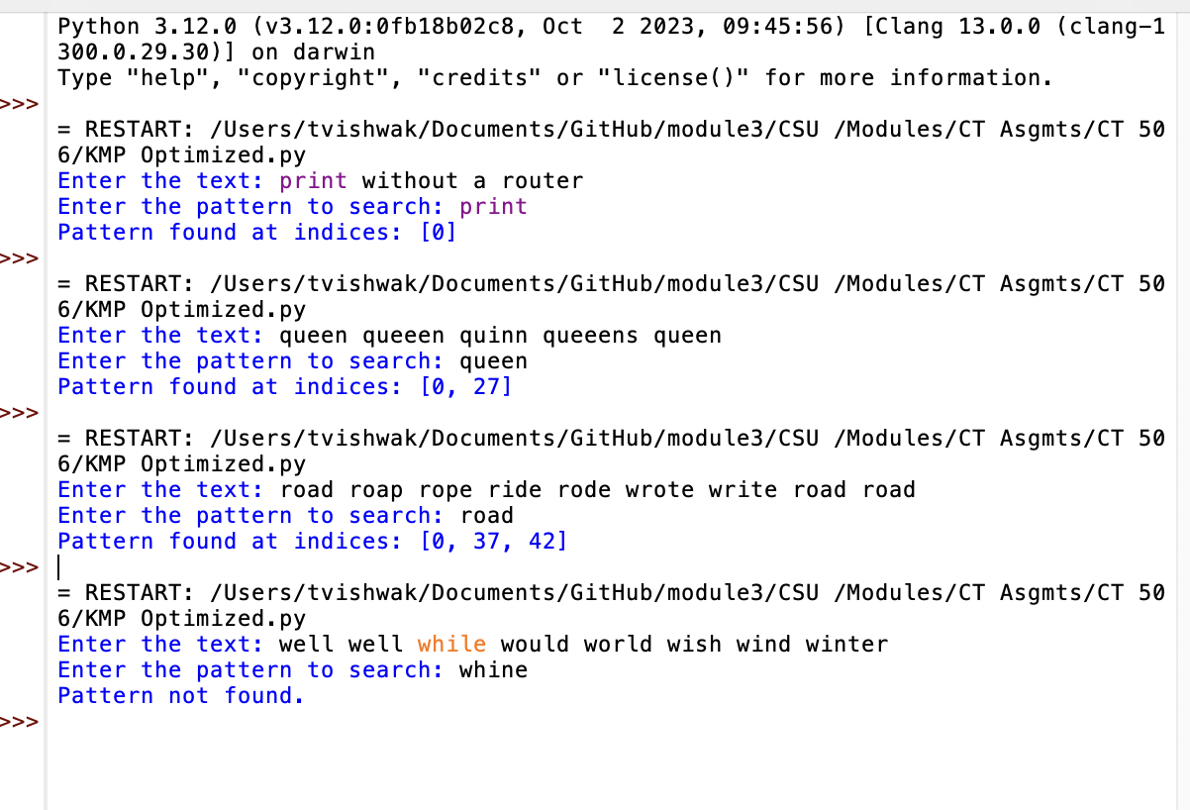

Rabin Karp Algorithm-
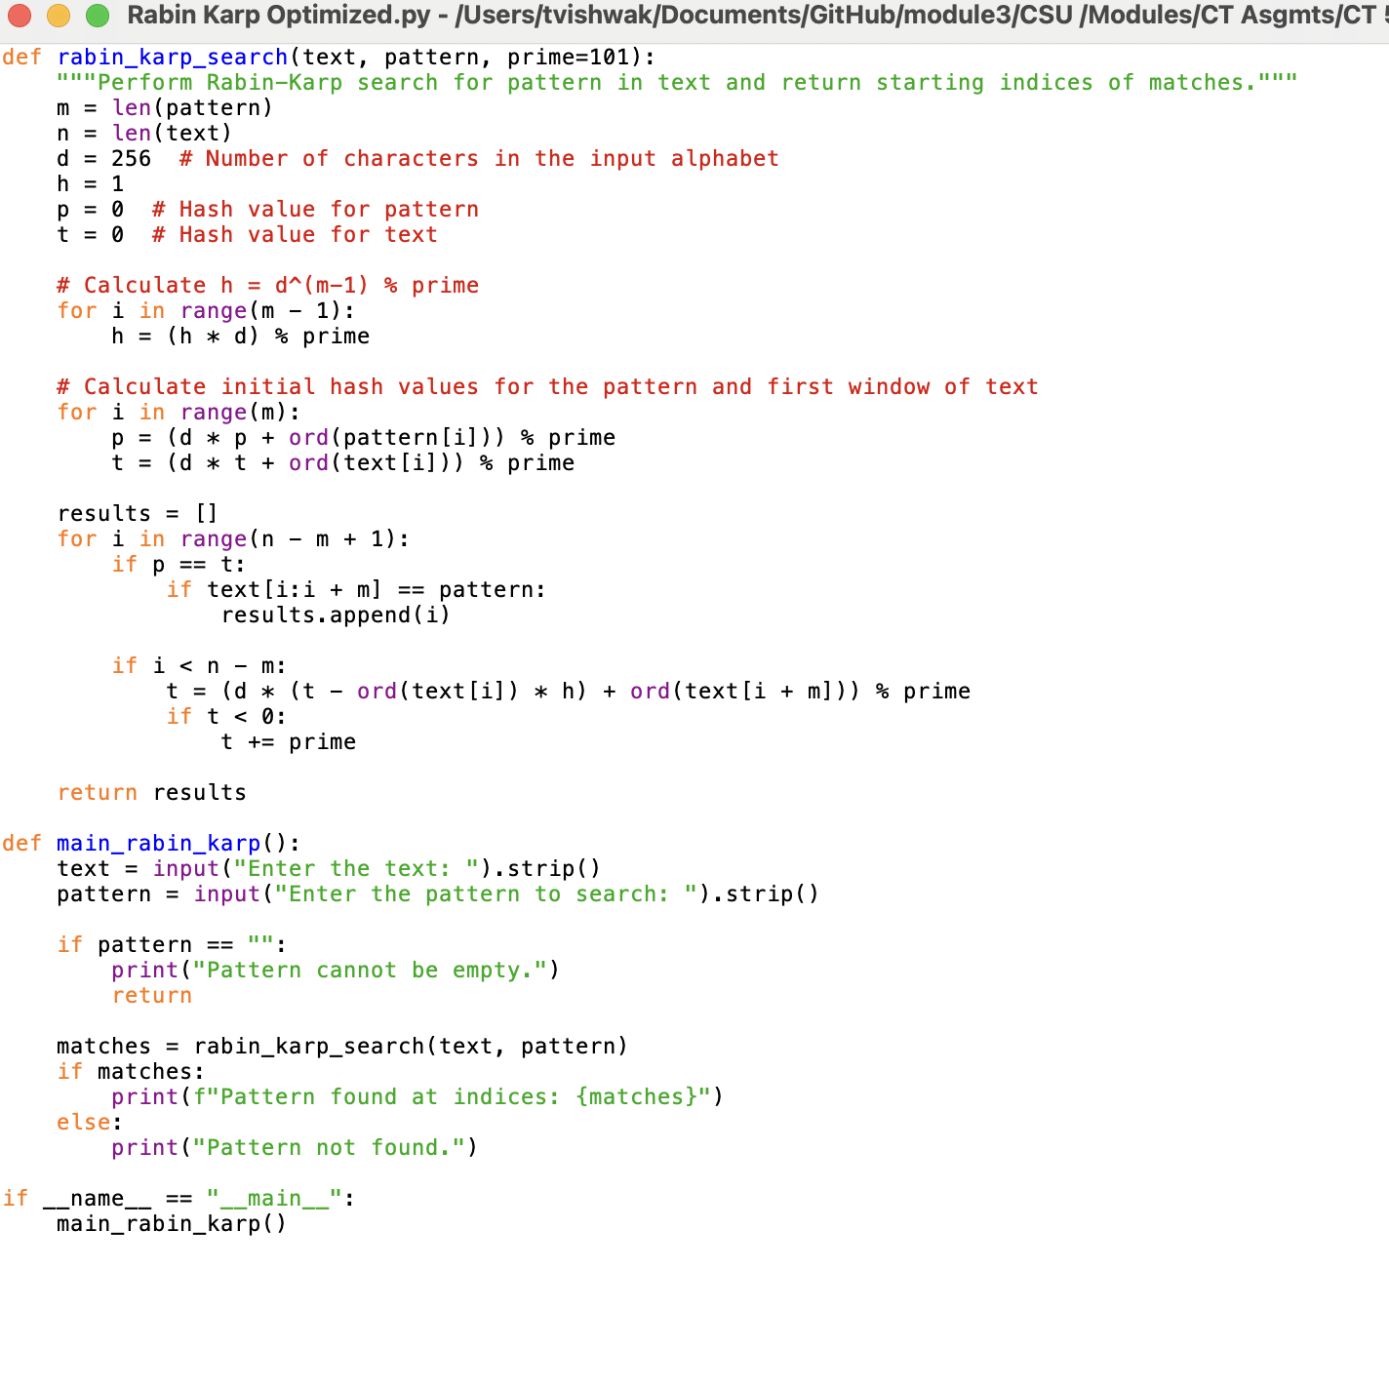

Execution-
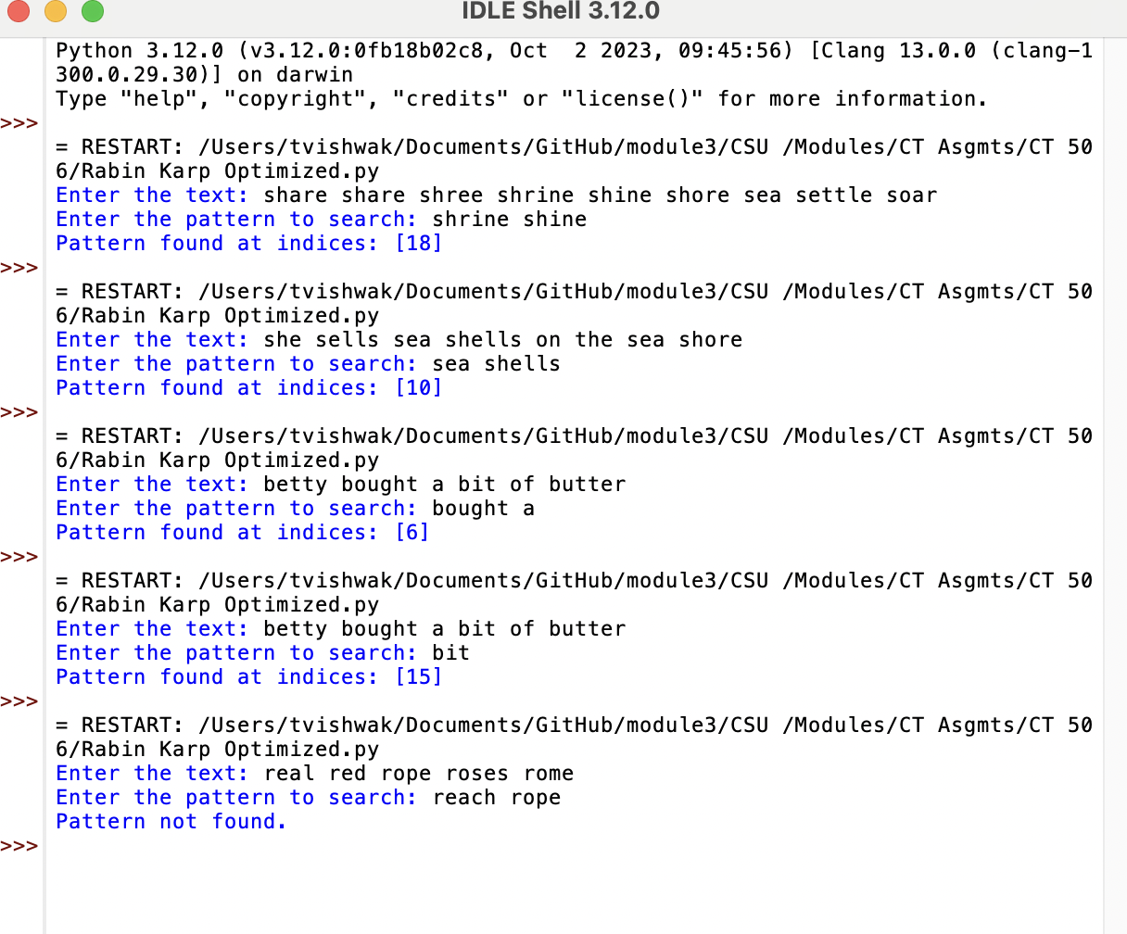

Conclusion
The Text Pattern Matcher tool effectively utilizes KMP and Rabin-Karp algorithms to address text searching needs. Despite initial challenges in algorithm complexity and performance optimization, these were overcome through careful implementation and testing. The empirical data analysis provided insights into the strengths and weaknesses of each algorithm, leading to targeted optimizations that improved their overall efficiency and reliability.

References
- Cormen, T. H., Leiserson, C. E., Rivest, R. L., & Stein, C. (2009). Introduction to algorithms (3rd ed.). The MIT Press.
- Knuth, D. E., Morris, J. H., & Pratt, V. R. (1977). Fast pattern matching in strings. SIAM Journal on Computing, 6(2), 323-350.
- Karp, R. M., & Rabin, M. O. (1987). Efficient randomized pattern-matching algorithms. IBM Journal of Research and Development, 31(2), 249-260.
- GeeksforGeeks. (2023). Knuth-Morris-Pratt (KMP) algorithm for pattern searching. Retrieved from https://www.geeksforgeeks.org/knuth-morris-pratt-kmp-algorithm-for-pattern-searching/
- Gusfield, D. (1997). Algorithms on strings, trees, and sequences: Computer science and computational biology. Cambridge University Press.

